Photoresists for Screen Printing Plates with High Resolution and Sensitivity Using Thiol-ene Reaction

**Haruyuki Okamura1*, Keiko Muramatsu2, Hideyuki Nakajiri2,**

**Masamitsu Shirai1, and Akikazu Matsumoto1**

*1 Department of Applied Chemistry, Graduate School of Engineering,*

*Osaka Prefecture University, 1-1 Gakuen-cho, Naka-ku, Sakai, Osaka 599-8531, Japan*

*2 Research and Development Center, Nakanuma Art Screen Co., Ltd.,*

*23 Uzumasa Yasui Okuhata-cho, Ukyo-ku, Kyoto 616-8082, Japan*

*\*okamura@chem.osakafu-u.ac.jp*

Photoresists for high resolution screen printing plates was devised using thiol-ene reaction. New resist formulation contains a base polymer which contains acid-labile tetrahydropyranyl-protected carboxylic acid, hydroxyl and methacrylic functions. As crosslinkers, multifunctional acrylates and multifunctional thiols were employed. Photoacid generators were used for pattern formation. A 6-m feature size of resist on a SUS screen plate was obtained on irradiation at 365 nm and followed by development. Post-exposure curing using 254 nm light with photoradical generators improved the mechanical characteristics of the resist patterns. Addition of a multifunctional thiol compound was effective to improve flexibility of the cured resist and resist sensitivity.

**Keywords: Screen printing plate, Photoresist, Thiol-ene reaction, High resolution, High sensitivity**

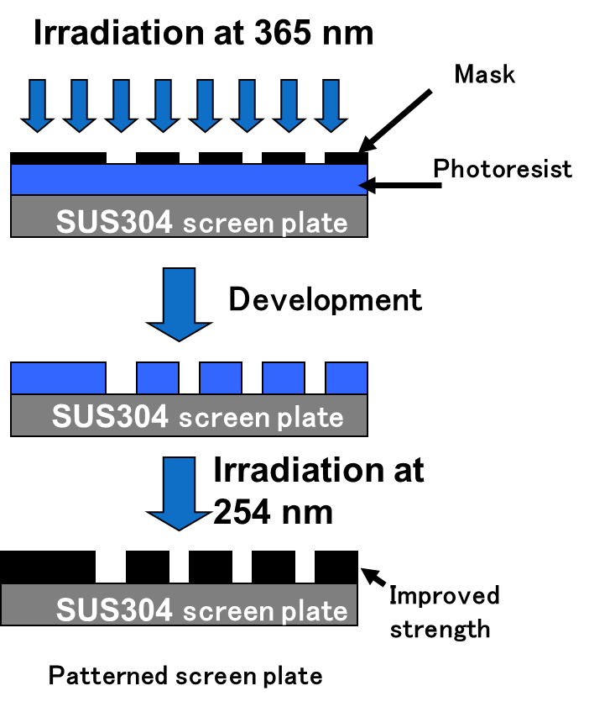

**1. Introduction**

Screen printing is a promising method to fabricate small feature size patterning of circuits for the production of electronic devises in terms of not only economical but also environmental issues compared to conventional lithographic methods. In this point of view, we have developed the photoresists for screen printing plates with high resolution [1-5]. The fabrication process of the screen plates is depicted in Fig. 1. The photoresist patterns contained a base polymer, a crosslinker, a photoacid generator (PAG) [6], and a photoradical generator (PRG) [7].

In this work, high-resolution screen printing plates were devised based on the findings previously reported [1-5]. New resist formulation contains a base polymer, which consists of acid-labile tetrahydropyranyl-protected carboxylic acid, hydroxyl, and methacrylic functions. As crosslinkers, multifunctional acrylates and thiols were employed. PAGs were used for pattern formation. Curing reactions of the acrylates are strongly inhibited in the presence of oxygen. The

Fig. 1. Schematic illustration for the fabrication of screen plates.

oxygen inhibition was effectively suppressed by the use of thiol-ene photocuring system due to regeneration of thiyl radical in the presence of oxygen [8-10] (Scheme 1). Thus, application of thiol-ene system may afford high resist sensitivity and durability. Effect of the structures of thiol compounds on flexibility of the cured resist and resist sensitivity was also investigated.



Scheme 1.Mechanism of thiol-ene reaction.



Scheme 2.Reaction mechanism of pattern formation on irradiation at 365 nm.

Scheme 3.Reaction mechanism of crosslinking on irradiated at 254 nm.

**2. Experimental**

The PAG diphenyl[4-​(phenylthio)​phenyl]​ sulfonium hexafluorophosphate (DPPTPSHFP) (product name: CPI-100P) (49 wt% propylene carbonate solution) was obtained from San-Apro Ltd. *N*-Trifluoromethanesulfonyloxy-7-*tert*-butylthianthrene-2,3-dicarboxylic imide (tBuTHITf) [11,12] (product name: SIN-11) was kindly donated by Sanbo Chemical Ind., Ltd. The PRG phenyl tribromomethyl sulfone (PTBMS) (Nacalai Tesque) was used as received. *O*-Benzoyl diacetone monooxime (BAOBE) [13] was prepared according to the literature. The crosslinkers DPHA (product name: A-DPH), and base polymer (product name: AP-HAR-201) were donated from Shin-Nakamura Chemical Co., Ltd. The difunctional thiol 1,1’-[(1-methylethylidene)- bis(4,1-phenylene-oxy-2,1-ethanediyl)] bis(3- mercaptobutylate) (BPMB) and the tetrafunctional thiol pentaerythritol tetrakis(3-mercaptobutylate) (PEMB) were obtained from Showa Denko K.K. and used as received. Chemical structures of the compounds are included in Schemes 2 and 3.

All sample films were prepared on silicon wafer by spin-casting or on poly(ethylene terephthalate) (PET) film (Cosmoshine A4100, 125 m, Toyobo Co., Ltd.) by bar-coating from solutions of toluene containing the base polymer, the crosslinker, and a PAG and a photoradical generator. The sample films were dried on a hot plate at 90 oC for 1 min. The thickness of films was about 0.5 m. Irradiation was performed in air at 254 nm using a low-pressure mercury lamp (Ushio ULO-6DQ, 6 W) without a filter, at 365 nm using a Xenon lamp (Asahi Spectra MAX-301, 300 W) with a band-path filter for 365 nm, and at 230-420 nm using the Xenon lamp with a mirror which passes the light below 420 nm. The intensity of the light was measured with an Orc Light Measure UV-M02 and Ushio USR-45VA. Insoluble fraction was determined by comparing the film thickness before and after dipping into 2.38 wt% tetramethylammonium hydroxide (TMAH) solution or toluene for 10 min. Thickness of films was measured by interferometry (Nanometrics Nanospec M3000). The measurement of pencil hardness goes from the lowest to the highest pencil in order to determine the maximum hardness for scratching the surface of the film on silicon wafer (Method: JIS K 5600-5-4). The hardness of the film was determined relative to a standard set of pencil leads. The surface hardness is determined by scratching the leads across the coating at a controlled angle of 45°. The pencil hardness was measured using a pencil hardness tester (Imoto Machinery Co., Ltd.) with UNI pencil series supplied by Mitsubishi Pencil (Japan). Flexibility was evaluated in a cylindrical mandrel test according to JIS K5600-5-1. This test is performed using equipment in which the film coated on a PET film is attached and bent over a 5-mm-diameter glass rod. Flexibility is evaluated observing the presence or absence of cracks or defects in the film.

UV-vis spectra were taken on a Shimadzu UV-2400 PC. The patterns of the resists were observed using a Keyence digital microscope VHX-200. Screen printing was carried out using a screen-printing machine (LZ-1232, Newlong Seimitsu Kogyo Co., Ltd).

**3. Results and discussion**

3.1. Strategy

We selected the protected poly(methacrylic acid) by cyclic acetal units with methacryl side chains as a base polymer. The polymer widely used as a positive type photoresist using photoinduced-acid catalyzed deprotection of the cyclic acetal units [14] as shown in Scheme 2. Durability of the resist was improved by radical crosslinking reaction between the methacrylic group in the side chain of the base polymer and the crosslinkers with the thiol as shown in Scheme 3. Addition of thiol compounds affords the high efficiency of the crosslinking reaction.

Selection of PAG and PRG of the resists was very important in addition to the choice of light sources. We selected 365 nm-light which is emitted from a medium-pressure mercury lamp and 254 nm-light from a low-pressure mercury lamp. It is required that PRG did not affect the pattern formation by the decomposition of the PAGs on irradiation at 365 nm. Thus, the absorbance of the PRG at 365 nm must be much lower than that of PAGs on the resist formulations. Figure 2 shows the UV-vis spectra of the PAGs 　(DPPTPSHFP and tBuTHITf) and the PRGs (BAOBE and PTBMS) in acetonitrile. As shown in Fig. 2, the absorbance of the tBuTHITf was larger than that of DPPTPSHFP at 365 nm. The absorbance of BAOBE was larger than that of PTBMS.

On irradiation at 254 nm, the PRGs and PAGs absorb the light to form radicals [6,13,15] and acids [7,11,16-21], respectively. The produced acid promotes the deprotection reaction of tetrahydropyranyl-protected units to form 3,4-dihydro-2*H*-pyran, which affects not only the crosslinking reactions including thiol-ene reaction but also the mechanical properties of the resist.



Fig. 2. UV-vis spectra of DPPTPSHFP (solid line), tBuTHITf (broken line), BAOBE (bold line), and PTBMS (bold and dotted line) in acetonitrile (1.0 x 10-4 M). For comparison, UV-vis spectrum of DPPTPSHFP (2.0 x 10-3 M) is also shown.

Thus, the balance of the generation of radicals and acids is important to improve the resist performance.

Table 1. Effect of formulation on sensitivity and mechanical property of the resist.



3.2. Formulation

To improve the performance of the resist, optimization of the resist formulation was required. The effect of PAGs, PRGs and thiols on resist performance was investigated. Especially, role of thiol compounds against the resist performance was mainly discussed.

We summarized the effect of formulation on sensitivity and mechanical property of the resist in Table 1. In this work, the methacryl monomer DPHA having six functionalities was employed. It is known that the crosslinker having high functionalities is effective to crosslink and enhance the hardness of the resists.

The effect of formulation on sensitivity on irradiation at 365 nm was investigated. The best sensitivity was obtained using tBuTHITf as a PAG, which is due to the strong absorption at 365 nm as shown in Fig. 2. In addition of the thiol compound PEMB increase the sensitivity because PEMB acts as a dissolution promotor and PEMB increases the flexibility of the resist, which enhances the deprotection reaction of the base polymer. Addition of the PRGs PTBMS and BAOBE did not affect the resist sensitivity, which indicates that the PRGs do not absorb 365 nm-light. Thus, thiol-ene reaction does not occur on irradiation at 365 nm.

The effect of formulation on solvent resistance, flexibility, and hardness of the crosslinked resist on irradiation at 254 nm was investigated. Solvent resistance of the crosslinked resist increased with irradiation dose for all formulations. Addition of PEMB drastically increased the solvent resistance. BAOBE was more effective than PTBMS due to larger absorption at 254 nm. When the formulation of the resist was [base polymer]/ [DPHA]/[PEMB]/[DPPTPSHFP]/[BAOBE] = 100/7/14/2/1.2 by weight, the highest sensitivity (< 10 mJ/cm2) for the solvent resistance was observed among the all formulations.

Using BAOBE as a PRG, flexibility of the crosslinked resist was investigated. Crosslinked resist loses its flexibility with irradiation dose due to high crosslinking density. Flexibility is very important for printing. The flexibility was enhanced by the addition of PEMB which incorporate the flexible units in the crosslinked resist with high solvent resistance. The high flexibility was also appeared by the pencil hardness of the crosslinked resist. Structures of PAGs did not affect the mechanical properties.

The effect of the structure of the thiols on the sensitivity and the mechanical properties of the resist were investigated using PEMB and BPMB. The formulation of the resist was fixed to [base polymer]/[DPHA]/[thiol]/[DPPTPSHFP]/[BAOBE] = 100/10/10/2/1.2 by weight. On irradiation at 365 nm, the resist sensitivity using PEMB was similar with that using BPEM, which is due to no interference on the photoinduced-acid catalyzed deprotection reaction as shown in Scheme 2. On irradiation at 254 nm, the effect of the structures of the thiols was not appeared due to the high sensitivity of the thiol-ene system. Thus, a xenon lamp which emits continuous spectra between 230-420 nm was used. The resist containing PEBM showed higher performance than that of BPMB on the solvent resistance and hardness. The resist containing PEMB showed the same flexibility as that of BPMB. Thus, we conclude that the tetrafunctional thiol PEMB is better than BPMB having two functionalities.

3.3. Evaluation of screen plate

The effect of thiols on resist performance was investigated by the fabrication of screen plates on stainless steel screens. Three kinds of resist formulations were investigated. Table 2 shows the resist formulations and the sensitivity of the resist on irradiation at 365 nm for the formation of line and space pattern as shown in Fig. 3. The sensitivity was strongly affected by the content of DPHA and DPPTPSHFP. Addition of PEMB in the resist formulation did not affect the sensitivity of the resist. The optical microscope images of top side and bottom side of screen plates in Fig. 3 revealed that line and space patterns with the resolution of 11.5 and 8.5 m was clearly observed. Some defects were appeared in only the screen plate containing PEMB. The results indicate that PEMB gives negative effect on resist resolution due to some side reaction. Optimization of the formulation of the resist may circumvent the problem.

We have successfully fabricated the screen plates with 6-m resolution as shown in Fig. 4. Durability of the screen plates was also investigated using the finest screen plates with 6-m line and space widths. Figure 4 shows the optical microscope images of the screen plate with (a) and without ((b), (c)) PEMB before and after printing 100 sheets.

Before printing, 6-m line and space patterns were clearly obtained for the both resists. After printing 100 sheets, the damages of the resist without PEMB pattern were clearly observed as shown in Fig 4 (c). On the other hand, no damage was observed for the screen plate without PEMB. Thus, the addition of PEMB enhances the toughness of the resist on the screen plates. The result is consistent to the observation of enhanced flexibility and hardness of the crosslinked resists in addition of PEMB.

Table 2. Resist formulation and sensitivity the resist for screen plate.



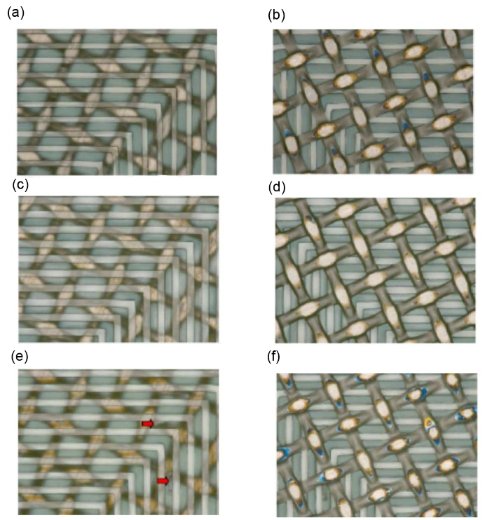

Fig. 3. Optical microscope images of top side ((a), (c), (e)) and bottom side ((b), (d), (f)) of screen plates.

L/S width: 11.5/8.5 (m/m).

Formulation: (a), (b); [base polymer]/[DPHA]/ [DPPTPSHFP]/[BAOBE] = 100/33/5/1 by weight.

(c), (d); [base polymer]/[DPHA]/[DPPTPSHFP]/ [BAOBE] = 100/10/2/1.2 by weight.

(e), (f); [base polymer]/[DPHA]/[PEMB]/ [DPPTPSHFP]/[BAOBE] = 100/10/10/2/1.2 by weight.

Arrows in (e) represent the positions of defects.

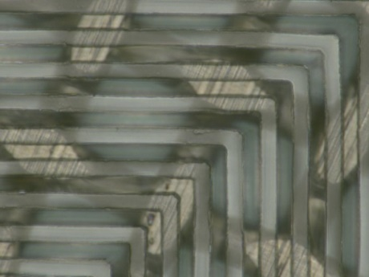(a)

(b)



(c)

Fig. 4. Optical microscope images of screen plate before ((a), (b)) and after (c) printing 100 sheets.

L/S width: 6/6 (m/m).

Formulation: (a) [base polymer]/[DPHA]/[PEMB]/ [DPPTPSHFP]/[BAOBE] = 100/10/10/2/1.2 by weight.

(b), (c); [base polymer]/[DPHA]/[DPPTPSHFP]/ [BAOBE] = 100/10/2/1.2 by weight.

**4. Conclusion**

A 6-m feature size of resist on a SUS screen plate was obtained on irradiation at 365 nm and followed by development with aqueous alkaline solution. Highest sensitivity was accomplished using tBuTHITf as a PAG. Post-exposure curing using 254 nm light with the PRG improved the mechanical characteristics of the resist patterns. BAOBE was more sensitive than PTBMS as the PRG. Resist durability was enhanced by the addition of thiols. PEMB having 4 functionalities was effective to enhance the resist durability.

**Acknowledgement**

This work was partly supported by a Grant-in-Aid for projects to support the advancement of strategic core technologies in contingency reserve of fiscal 2010, from MITI, Japan.

**References**

1.   H. Okamura, M. Kayanoki, K. Takada, H. Nakajiri, K. Muramatsu, M. Yamashita, and M. Shirai, *Polym. Adv. Technol.*, **23** (2012) 1151.

2.   K. Takada, J. Hamuro, T. Matoba, M. Yamashita, M. Shirai, and H. Okamura, Japan Patent JP 2015-59160A (2015).

3.   K. Takada, J. Hamuro, T. Matoba, M. Yamashita, M. Shirai, and H. Okamura, Japan Patent JP2016-172811A (2016).

4.   K. Takada, *Mater. Stage*, **15** (2015) 16.

5.  L. Wang, J. Pfeifer, C. Balázsi, I. M. Szilágyi, and P. I. Gouma, *Proc. SPIE*, **6769** (2007) 6769E1.

6.   J. V. Crivello and E. Reichmanis, *Chem. Mater.*, **26** (2014) 533.

7.   B. M. Monroe and G. C. Weed, *Chem. Rev.*, **93** (1993) 435.

8.   C. E. Hoyle, T. Y. Lee, and T. Roper, *J. Polym. Sci. Part A: Polym. Chem.*, **42** (2004) 5301.

9.   Q. Li, H. Zhou, and C. E. Hoyle, *Polymer*, **50** (2009) 2237.

10. C. E. Hoyle and C. N. Bowman, *Angew. Chem. Int. Ed.*, **49** (2010) 1540.

11. H. Okamura, H. Naito, and M. Shirai, *J. Photopolym. Sci. Technol*., **21** (2008) 285.

12. M. Shirai, H. Okamura, and M. Takahashi, Japan Patent JP5126873B (2012).

13. S. I. Hong, T. Kurosaki, and M. Okawara, *J. Polym. Sci. Polym. Chem. Ed.*, **12** (1974) 2553.

14. G. N. Taylor, L. E. Stillwagon, F. M. Houlihan, T. M. Wolf, D. Y. Sogah, and W. R. Hertler, *Chem. Mater.*, **3** (1991) 1031.

15. D. L. Fields, Jr. and H. Shechter, *J. Org. Chem.*, **51** (1986) 3369.

16. J. L. Dektar and N. P. Hacker, *J. Am. Chem. Soc.*, **112** (1990) 6004.

17. M. Shirai, *J. Photopolym. Sci. Technol.*, **20** (2007) 615.

18. H. Yamamoto, T. Asakura, Y. Nishimae, A. Matsumoto, J. Tanabe, J.-L. Birbaum, P. Murer, T. Hinterman, and M. Ohwa, *J. Photopolym. Sci. Technol.*, **20** (2007) 637.

19. T. Asakura, H. Yamato, and M. Ohwa, *J. Photopolym. Sci. Technol.*, **13** (2000) 223.

20. M. Shirai and M. Tsunooka, *Prog. Polym. Sci.*, **21** (1996) 1.

21. H. Okamura, “Hikari-kagaku no jiten”, Asakura Pub. Co., Tokyo (2014) p. 190 (in Japanese).